Community Arts Walkway

Wall 1
Dimensions of hanging space: 93cm, door, 87cm, window, 685cm, door, 100cm.
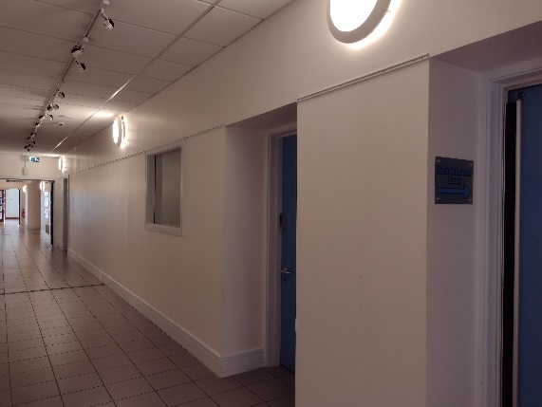

Wall 2
Dimensions of hanging space: 160cm, pillar for poster with info, 537cm, 57cm pillar, 300cm, alcove.
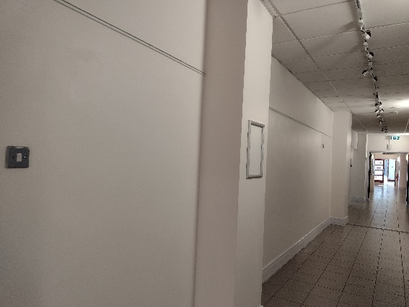
Wall 3
Dimensions of hanging space: 220cm, 57cm pillar, 535cm, 57cm pillar, 400cm.
