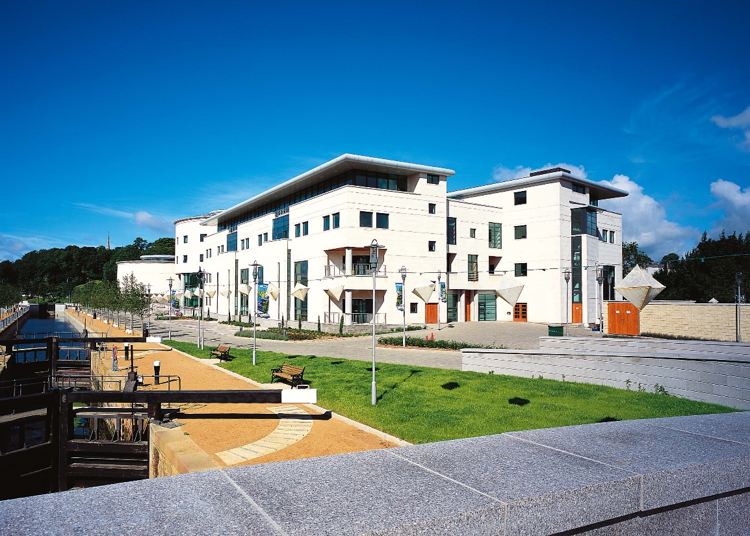
Directions to ISLAND Arts Centre, ISLAND Civic Centre, Lagan Valley ISLAND, Lisburn BT27 4RL
Travelling from the south of Lisburn
- From the M1 take the second turnoff for Lisburn (Saintfield Road)
- From the slip road take the first turn off the roundabout onto the Saintfield Road
Travelling from the north of Lisburn
- From the M1 take the first turnoff for Lisburn (Saintfield Road)
- From the slip road take the third turn off the roundabout

Directions are then as follows:
- Travel along the Saintfield Road through the first sets of traffic lights
- Once through these lights (you are now on Sloan Street) make sure you are in the right hand lane
- Go through the next set of traffic lights
- At the round about take the second turn off onto the Queen's Road (stay in the right hand lane)
- The turn off for Lagan Valley Island is the first on your right. Traffic lights are in operation to filter you onto the Island
- Travel along the front of the building and across the Jubilee Bridge to the main car park.
​
