Gallery 545 Group Exhibition ONLINE
Island Arts Centre Virtual Gallery
islandartscentre.com
January – February 2021

List of artists and their works
(in alphabetical order)

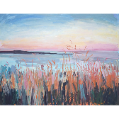 | Lisa Ballard, North Coast Summer Sunset, 2020, oil and spray paint on canvas, 91 x 71 x 2 cm (36 x 28 in), £2000
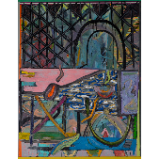 | Ronan Bowes, Undeclared, 2019, oil on canvas, 90.5 x 118.5 cm (98 x 126 cm with artist frame), £2500
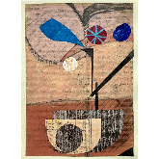 | Alacoque Davey, Autumn Fruits, 2020, Sennelier oil pastel and hand coloured Kraft paper collage on Fabriano 300gm paper, 21 x 23 cm (30 x 40 x 1 cm framed), £245
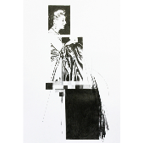 | Craig Donald, Eva Supported by Her Gown, 2020, pencil on 200GSM card, 21 x 30 cm (33.5 x 42.5 x 2.5 cm framed), £320
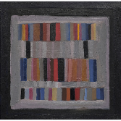 | Ray Duncan, Stacks, 2019, oil on canvas, 40 x 40 x 2 cm, £450
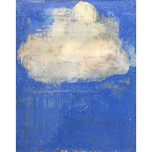 | Karl Hagan, What Courage, 2020, oil on canvas, 40 x 50 x 3 cm, £375
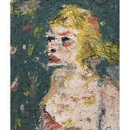 | Elham Hemmat, Portrait 1, 2020, acrylic paint and natural pigments on canvas, 50 x 60 x 2 cm, £350
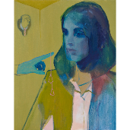 | Trina Hobson, Enjambment, 2020, oil on canvas, 60 x 76 x 2 cm, £850
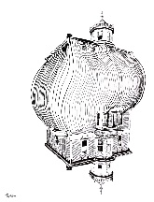 | Ashley B. Holmes, Untitled, 2020, ink on artist marker paper, 42 x 29 cm, £300
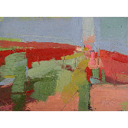 | Janet Keith, Hotscape, 2018, oil on board, 25 x 19 cm (38 x 32 x 3 cm framed), £375
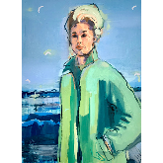 | Rachel Lawell, The Birds, 2020, oil on canvas, 60 x 80 x 2 cm, £680
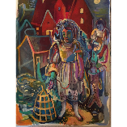 | Rosie McGurran, The Red House on the Corner, 2019, acrylic on paper, 20 x 29 cm (42 x 49 x 2.5 framed), £675
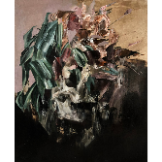 | Aimee Melaugh, Vain Exterior, 2019, oil on canvas, 50 x 60 x 4 cm, £500
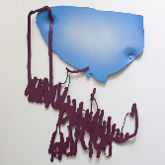 | Kevin Miller, Hopes Shrank, 2017, acrylic on acrylic sheet, 56 x 42cm, £475
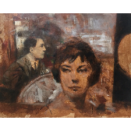 | Noel Murphy, Untitled, 2020, acrylic on canvas, 50 x 60 x 2 cm, £2500
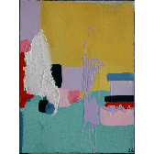 | Latisha Reihill, Lemonade Lake, 2020, acrylic paint and other media on canvas, 30 x 40 x 3 cm (34 x 44 x 4 framed), £460
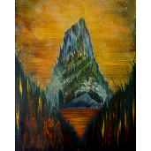 | Charlie Scott, The Flood, 2020, oil on canvas, 61.5x 76.5 x 2.5 cm, £600
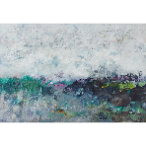 | Katherine St Angelo, Defining the Elements 8, 2020, acrylic paint and ink on linen, 63 x 43.5 cm (66 x 46.5 x 4 cm framed, lime tray frame), £675
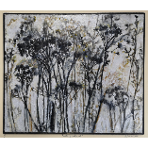 | Anushiya Sundaralingam, Kattuppukkal (Wild Flowers), 2020, oil paint and other media on board, 34 x 29 cm (52 x 48 x 3.5 cm framed), £400

Artworks can also be viewed online at gallery545.com
For sales and enquiries, contact Francesca Biondi
at hello@gallery545.com or on +44 7960 130414

